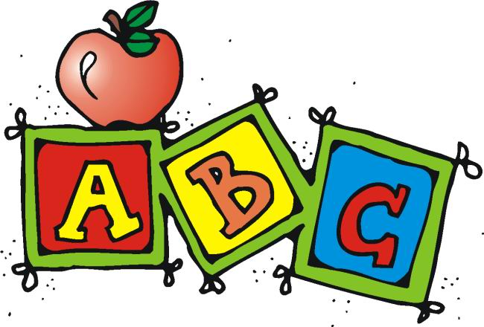

**Upcoming Info and Reminders**

* **August 14th –** Last day to walk kindergarteners to class
* **August 14th-31st –** PTO Membership Drive
* **August 18th –** Snack Cart
* **August 21th-September 15th –** School Spirit Wear for sale
* **August 24th –** PTO Meeting in gym at 6:15 PM/Marco’s Pizza Night
* **August 25th –** Snack Cart
* Please send money for the journal ($4.00) and tablet ($2.50). Please send exact cash or a check ($6.50).
* Bring a **snack EVERY DAY**. We have snack at 9:30 after our related arts.
* Please make sure all money is labeled with purpose and your child’s name in their zipper pouch in their binder.
* Lunch is $2.25 if you plan to buy lunch.
* Please send an extra change of clothes.

**Snack Cart**

* Snack cart is on Fridays and some other days throughout the year. Days will be listed on this newsletter and the school’s calendar.
* Prices range from $0.25 to $2.00. There are things from pop tarts and cinnamon rolls to candy bars and Gatorade. There are also special items around holiday times.

**Mrs. Lauren’s News**

**lgoodwin@tipton-county.com**

**August 14-18, 2023**

**Our Weekly Skills**

* Practice of class rules and procedures/routines
* **Stories for the week:** *Chicka, Chicka Boom Boom and Nursery Rhymes*
* **Literacy:** Listening to environmental noises
* **Tricky Words:** I, can
* **Writing:** Practice writing first name with the first letter capitalized
* **Math Skills:** Counting to 25; count, recognize, and make 1-5

**Ways to help at home**

* Review our weekly skills
* Read to your child each night
* Complete Weekly Literacy Practice

**Literacy Practice**

This is where you will find our sight words, the letters/phonics skill for the week, and words/sentences to read. Please practice every night.

**Read these sight words.**

(Your child should practice reading these quickly and without hesitation.)

**I can**

**Letters:**

In the next few weeks, you will see specific letters to focus on. For now, please practice identifying the letters of the alphabet and the sounds they make.