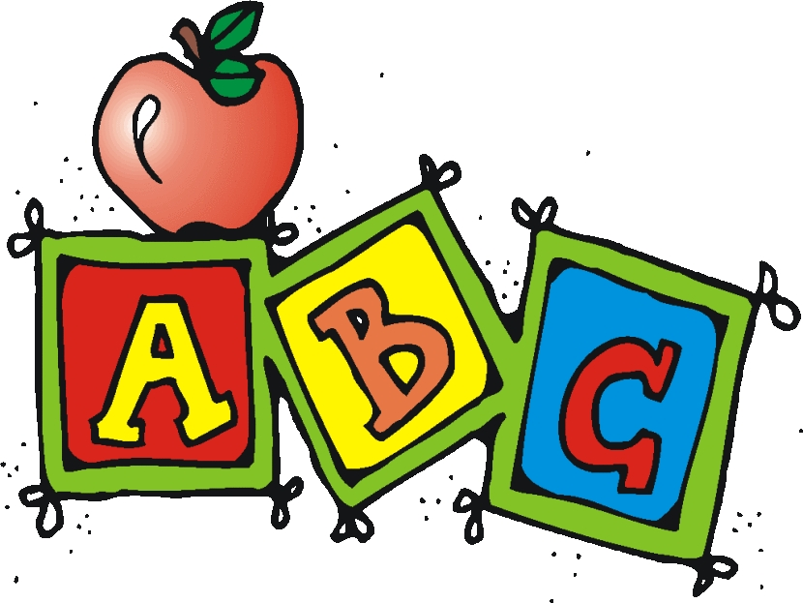
ABC’s of Kindergarten
Absences - Please be sure to send a note when your child returns to school. Notes should be sent in your child’s folder/binder. Notes should include the date of the absence, your child’s first and last name, your name, and the reason for the absence.
Assessment – Easy CBM testing, ongoing assessments, Spelling and Reading Tests
Arrival/Attendance - Students should have time to arrive to our classroom by 7:45. If you plan for your child to eat breakfast at school, please arrive by 7:30. They are tardy at 7:50. Four tardies equal one absence for attendance purposes. After 6 parent notes/absences, your child must have a doctor’s note.

Binders - Your child will bring this binder home from school each day. Inside the binder, you will find:

1. The Front (Left) Pocket: The front pocket of the binder will be to send things home that need to be returned to school. Periodically, you may be asked to sign and return things like, progress reports, report cards, permission slips, etc.

2. The Back (Right) Pocket: The back pocket of the binder will be used to send things home that will be left at home. This includes notes and daily student work. Please be sure to read the notes sent home.

3. Money/Notes Pocket: This is the clear pencil pocket in the binder!! Please put any money and transportation/dismissal notes in this pocket. Please be sure money is in a labeled envelope or Ziploc baggie.

4. Newsletter: I will put the weekly newsletter in your child’s binder. Please review the newsletter each week to see what we are doing in class that week and any class announcements and reminders.

5. Tricky Word List: Your student will be tested on these words. Please practice at home. This list includes all tricky words for the school year.

6. Skills List: These are the skills tested for the report card for each nine weeks.

Birthdays - Birthdays are important to us! Their name will also be announced during morning announcements. You may not send in any edible treats due to food allergies. Ice cream is available for you to purchase for the class (cost is $1). Students will receive a special treat from me on their birthday!

Breakfast – Breakfast will be served daily from 7:00-7:40. If your child is going to eat breakfast, they must be in the cafeteria before 7:40. If your child is eating breakfast, they will need to know their breakfast/lunch number. Breakfast is $1.00
Change of Clothes - Please send an extra change of clothes for your child, just in case an accident happens.
Communication - Please refer to the weekly newsletter to help answer any questions. You may write a note in the binder, message me on class Dojo, or call/leave me a message at school. I will respond to you as quickly as possible.
Conduct - Your child’s conduct will be located in the appropriate dated section of the binder. Each night have regular conversations with your child about his or her behavior and sign your initials to indicate you have seen conduct daily.
Donations - Please see our wish list on our class newsletter. I appreciate any donations you make to our classroom!
Early Dismissal - We will dismiss early a few days this school year. Dismissal times will be listed in the newsletter.
Emergency Dismissal - Weather conditions may dictate that we dismiss early. Please make sure that all emergency contact and dismissal information is current.
Illness – Tipton County Schools practice a 24 hour fever-free (without any fever reducing medication) before your child may return to school.
Keep Reading - This is a very important time in your child’s life. He or she will soon begin reading! Think about setting aside a time each night to read for about 10-15 minutes. At first, this may be a time where you read to your child, but soon he or she will be reading to you!
Lunch – Lunch will cost $2.25. Students will eat in the cafeteria and will need to know how to open all their own containers. If your child is eating a school lunch, they will need to know their lunch number. Please practice at home. No lunch visitors will be allowed at this time.
Math - Just a few skills include number recognition and ordering numbers to 20; counting by ones, fives, and tens; counting to 100, identifying 2-D and 3-D shapes; and beginning to understand basic concepts of addition and subtraction.
Newsletter - A weekly newsletter will be sent home. Please be sure to read it to find out what we are up to in class and about any special days or events.
Parental Involvement - Your support of school activities makes your child feel important and sends the message that you value their education.
P.E. - In addition to library, music, art, health, and computer classes, your child will participate in P.E. You will be notified of our P.E. days. Please be sure your child wears tennis shoes for P.E.
P.T.O - Each year this organization works hard to provide activities and essentials for Atoka Elementary. Please show your support and appreciation by volunteering and supporting whenever possible.
Recess - Based on our schedule and weather, we will have either outside or inside recess daily.
Sight Words/Tricky Words - Please take a look at these words that must be mastered in your child’s folder and newsletter.
Snack - We will have a short snack time each morning. Please be sure to send one snack that can easily be opened by your child. Please send water for your child to drink. Snack time will last about ten minutes.
You - You are your child’s first teacher. Encourage your child to practice his or her new skills in real life (shoe tying, noticing that you use a clock at home, watching you measure while cooking, identifying letters and words in a book as you read together, etc.).
ZZZ’s - Please be sure your child gets plenty of sleep each night.

