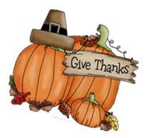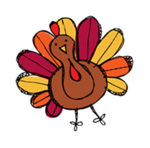

**Our Weekly Skills**

* **Stories for the week:** *Farms*
* **Literacy:** Letters Bb, Ll, Rr, Uu
* **Tricky Words:** Blue
* **Writing:** Practice writing last name correctly without a model and letters learned, write an opinion piece
* **Math Skills:** Count to 50, count by 10’s to 100, and classifying and counting data

**Ways to help at home**

* Review our weekly skills
* Read to your child every night
* Complete weekly literacy practice
* Practice tying shoes

Review our

**Literacy Practice**

Name these letters and make the sounds.

**M T D A O C V P G I**

**N S F H B L E Z R U**

**d m t a o c v p g i**

**n s f h e b z l r u**

Read these tricky words.

(Your child should practice reading these quickly and without hesitation.)

**I see can the like**

**three and blue one**

**two are yellow look**

Read the sentences.

**I can see the pig on the mat!**

**Can I see the pig on the blue mat?**

**Upcoming Info**

* **November 1st-17th -** Yearbook Sales. The cost is $40
* **November 7th –** School Fundraiser Items Pickup 3:30-6:00
* **November 8th –** ATES Spirit Day – wear your favorite ATES shirt
* **November 9th –** Fall Picture Money Due
* **November 9th –** Field Trip to the Zoo. Wear Tennis Shoes
* **November 10th –** Veterans Day Parade at 8:30/Snack Cart
* **November 14th –** ATES Spirit Day – wear your favorite ATES shirt
* **November 16th** – School Christmas Pictures/Snack Cart/Progress Reports sent home/PTO Meeting at 6:00/Marcos Pizza Night
* **November 17th** - Snack Cart
* **November 20th – 24th** – Thanksgiving Break
* **November 28th** - ATES Spirit Day – wear your favorite ATES shirt
* **November 29th** – Santa Shop Begins



**The Great Turkey Race and Thanksgiving Food Drive—Due by November 10th!**

https://www.signupgenius.com/go/60B0A4AAFAC23A7FB6-45612811-kindergarten

**Use the link above to sign up to send items for food baskets or send some dollars to purchase hams and turkeys by November 10th!**

**Mrs. Lauren’s News**

**lgoodwin@tipton-county.com**

**November 6-10, 2023**