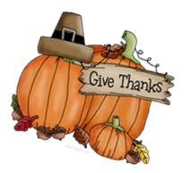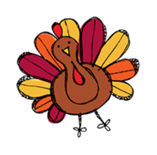

**Our Weekly Skills**

* **Stories for the week:** *Halloween Books, Plants*
* **Literacy:** Review
* **Tricky Words:** Review
* **Writing:** Practice writing last name correctly without a model and letters learned
* **Math Skills:** Count to 50, count by 10’s to 100, compare numbers 0-10

**Ways to help at home**

* Review our weekly skills
* Read to your child every night
* Complete weekly literacy practice
* Practice tying shoes

Review our

**Literacy Practice**

Name these letters and make the sounds.

**M T D A O C V P**

**G I N S F H E Z**

**d m t a o c v p**

**g i n s f h e z**

Read these tricky words.

(Your child should practice reading these quickly and without hesitation.)

**I see can the like**

**three and blue one two are yellow look**

Read the sentences.

**I can see the red and yellow pens.**

**Can I look at the three dots?**

**Upcoming Info**

* **November 1st-17th -** Yearbook Sales. The cost is $40
* **November 1st-10th -** Thanksgiving Basket and Great Turkey Race
* **November 2nd–** Parent/Teacher Conferences if you signed up for one
* **November 3rd –** Snack Cart
* **November 9th –** Fall Picture Money Due
* **November 9th –** Field Trip to the Zoo. Wear Tennis Shoes
* **November 10th –** Veterans Day Parade at 8:30
* **November 16th** - Snack Cart; Progress Reports sent home; PTO Meeting at 6:00; Marcos Pizza Night
* **November 17th** - Snack Cart
* **November 20th – 24th** – Thanksgiving Break

**Reminders**

* Bring **one** **snack EVERY DAY**. We have snack at 9:30 after our related arts.
* Please make sure all money is labeled (name and what it is for) in the zipper pouch.
* Lunch is $2.25 if you plan to buy your lunch.
* Please send an extra change of clothes.

**Notes from the office:**

* Car riders must be at school before 7:40 am.
* If students are not here before 7:50am they will have to go to the office for a tardy slip.



**Mrs. Lauren’s News**

**lgoodwin@tipton-county.com**

**October 30-November 3, 2023**